The Center for Justice, Law, and Societies is pleased to announce its inaugural class of Graduate Fellows. Fellows will participate in a year-long program to develop an interdisciplinary academic project related to justice, law and societies, and will receive conference funding, mentorship, and attend professionalization workshops. Congratulations!
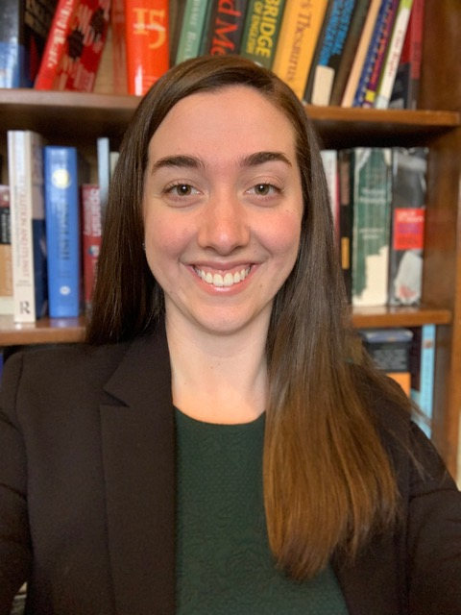
Katie R. Billings is a PhD Candidate in the Sociology Department researching inequality in the legal and mental health fields. Her work examines legal consciousness, access to justice, and, more generally, how the law creates and sustains social inequalities. Billings is currently working on a project with her co-author, Professor Kathryne Young, to examine how race and social class inform the ways that people navigate police-citizen interactions across time. Using open-ended responses to a series of vignettes about constitutional rights in the criminal procedure context, they examine how both race and class influence legal consciousness—the ways people interpret, experience, and mobilize the law—and assess whether these effects shift with changing political climates. In Billings’ dissertation research, which is funded by the National Science Foundation, she is interviewing people who have survived suicide attempts in order to examine how people make sense of their suicide experiences, and how those understandings relate to their post-suicide lives. Billings’ research is published in the Law & Society Review, Sociological Perspectives, and Social Science & Medicine. She also serves as the Editorial Assistant for the Law & Society Review.

Hannah Chimowitz is a PhD student in the Social Psychology program. She received her B.A. in Psychology and Philosophy from Rhodes College in 2014. Her research interests encompass topics related to emotion, social identity, and moral judgment, with projects focusing on questions at the intersection of social psychology and the law. In her primary lines of research, she examines how emotions are experienced, expressed, and perceived within the legal system, and the downstream effects of emotional processes on legal outcomes. Her Master’s research investigated the effects of victim gender and emotional displays within victim impact statements on legal judgments and decision-making. Other current projects include an investigation of the effects of defendant race and nonverbal cues on perceptions of remorse, moral judgments, and punishment decisions, as well as the development of a conceptual model describing self- and social- stigmatization of individuals with criminal records throughout the process of reentry.

Liliam Fiallo is a PhD student in the Department of Political Science. She has a degree in Law (2007) and a Master’s in Constitutional and Administrative Law (2011) from the University of Havana, Cuba. From 2011 to 2014, she studied in a Master’s in Social Sciences Program with a major in Sociology at FLACSO-Ecuador, and a Graduate Specialization in Public Policies and Gender Justice from CLACSO (2018). Since 2011, her research has been focused on the study of legal pluralism in Ecuador, and recently she has been conducting research in this field from a feminist perspective. Specifically, she analyzes indigenous women's access to justice in cases of gender-based violence. She is the author of the book "Legal Pluralism in Ecuador. The Case of Tsachila Nationality". Quito: UDLA, 2014 (in Spanish)

Carly McCann is an economics PhD candidate at the University of Massachusetts, Amherst. Her research interests include labor economics, discrimination and inequality, and feminist economics. As a research assistant at the UMass Center for Employment Equity, she researched geographical variation in occupational employment diversity and discrimination, with a particular focus on workplace sexual harassment. Her dissertation work examines the dynamics of contemporary workplace sex discrimination and the efficacy of existing legal and political institutions in place to redress employer discrimination in the United States. In particular, her research focuses on the workplace experiences of pregnant workers and the effectiveness of policies to address the needs of pregnant workers.

Christine (Chris) Bailey is a PhD student, Research Assistant, and Teaching Assistant in the Department of Political Science and Legal Studies. Chris specializes in Public Law or Law and Society Scholarship, Social Science Research Methodologies and Epistemologies, Feminist Theory, and Feminist Methodologies and Epistemologies. Most of her research centers on the way in which gender and race impact judicial decision-making and judicial behavior; and the way in which social movements and social movement litigation shape public policy and legal precedent. Chris currently serves as a research assistant for a National Science Foundation-funded project that examines LGBTQ+ media for coverage of rights claims and salient legal cases, to determine the social, legal consciousness of the LGBTQ+ community, over time. Chris has also published research on the gendered nature of precedent dissemination and transmission in U.S. State Supreme Court opinion citations.

