The Center for Justice, Law, and Societies is pleased to announce its second class of Graduate Fellows. Fellows will participate in a year-long program to develop an interdisciplinary academic project related to justice, law and societies, and will receive conference funding, mentorship, and attend professionalization workshops. Congratulations!
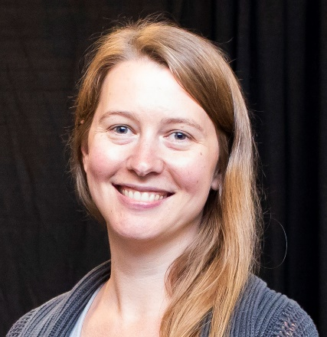
Faith English is a PhD student in Health Policy and Management in the School of Public Health and Health Sciences. Prior to enrolling in the graduate program at UMass, Faith worked in a variety of public health positions including as a Bilingual Home Visitor with teen parents in western Massachusetts and as a Client Navigator for people living with HIV and co-occurring substance use disorder and mental illness. Faith decided to pursue an advanced degree in order to conduct health policy research that addresses the significant structural barriers that marginalized communities face. As a PhD student, Faith is interested in ways to address the public health crisis of mass incarceration and the overrepresentation of communities of color in the United States criminal justice system which is caused in part by the “war on drugs”, launched in the 1970s. Efforts have been made to reduce incarceration rates, including the decriminalization and legalization of cannabis for adult use. The broad goal of her research is to examine the ways in which cannabis legalization may ameliorate or perpetuate the harms done by the war on drugs, particularly among youth of color in Massachusetts.
Catie Fowler is a doctoral student in International Relations, with a focus on understanding international and domestic perspectives on war law and civilian targeting in armed conflict. Specifically, she investigates why initiatives to increase women’s participation in security, such as the UN’s Women, Peace and Security agenda have gained popularity amongst liberal democracies and what mechanisms affect citizen perspectives on civilian targeting during warfare. As a feminist scholar, Catie maintains a deep commitment to the activist and policy implications of her work. Prior to coming to UMass, Catie received her B.A. in Anthropology from the University of Colorado and an M.A. in International Studies from the Josef Korbel School at the University of Denver. She has worked in policy on the Women, Peace and Security agenda and as a volunteer for the US Peace Corps in Rwanda.

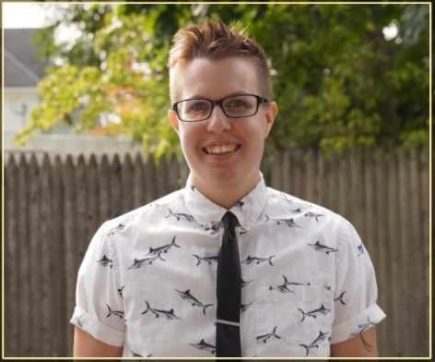
Shay Olmstead (they/them) is a doctoral candidate studying the history of queer and (trans)gender policies in the mid-twentieth century United States. Shay received their bachelor’s degree in American Indian Studies from Black Hills State University in Spearfish, South Dakota and went on to receive both a M.Ed. in Curriculum and Teaching from Fitchburg State University and a M.A. in History from the University of Massachusetts Amherst. They have comprehensive training in the fields of Modern US Gender and Labor history, the History of Sexuality and Gender, the History of Capitalism, and Native American History and Economic Self-Determination. Their dissertation, provisionally titled “Refuse to Run Away”: Employment Discrimination Lawsuits as Transsexual Activism, 1970-1990, argues that transsexual employment-discrimination lawsuits bucked an “unwritten rule” of transsexuality, constructed a federal, trans-exclusionary definition of “sex,” increased the visibility of transsexuality, and helped to develop a transsexual group consciousness. Standing at the intersections of the history of sex, gender, and sexuality, activist studies, labor history, and legal studies, their dissertation contributes to historians’ understanding of “biological sex,” midcentury and Cold War sex and gender norms, and movement activism. When they are not teaching, writing, or thinking about queer history, Shay can be found riding horses, hiking with their dog, Scout, baking, sewing, or otherwise enjoying life in the Pioneer Valley.

Jordan Sanderson is a PhD student in the Department of Sociology and is currently pursuing the Graduate Certificate in Feminist Studies in the Department of Women, Gender, & Sexuality Studies. Their intellectual interests lie in Trans/Queer Politics, Law & Society Scholarship, and Critical Theory. Jordan’s previous research has focused on studying homophobic scripts deployed during Supreme Court arguments, legal and social activism utilized by organizations like the Lambda Legal Defense and Education Fund, and transgender theory-building through everyday resistance and artistic mediums. Their ongoing research seeks to provide theoretical insight on trans/queer related legislation constructed by state lawmakers to investigate the epistemological positions that they take when crafting laws and introducing them to their legislative chambers.

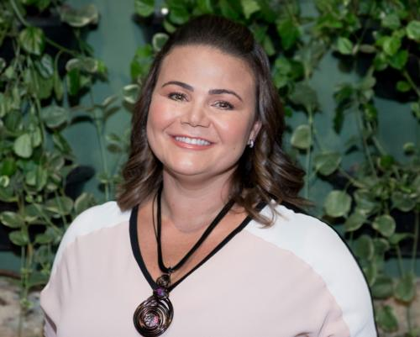
Grazielle (Grazi) Valentim is a third year graduate student at the University of Massachusetts, Amherst, where she is pursuing a Ph.D. in Sociology. Her research interests focus on immigration and labor rights, gender, family, and care work, examining the regulation and work of au pairs in the United States through the J-1 visa programs. Her work explores how the State Department, sponsored au pair agencies, and states, like Massachusetts, apply laws to au pairs, given that the program is recognized as “cultural exchange” rather than migrant labor. She also studies the contrasting experiences of women and men au pairs as well as the experiences of host parents accounting for different family formations through the lens of gender, sexuality, class, work, and family. She is the recipient of the National Science Foundation Graduate Research Fellowship and the Research Enhancement and Leadership (REAL) Fellowship, which provide her with substantial support for her dissertation research. Grazi received a BA in Sociology (with Honors) and Gender & Sexuality Studies from University of California, Irvine, summa cum laude, in 2018. Grazi’s research interests stem from her personal experiences as an immigrant domestic worker in the United States.

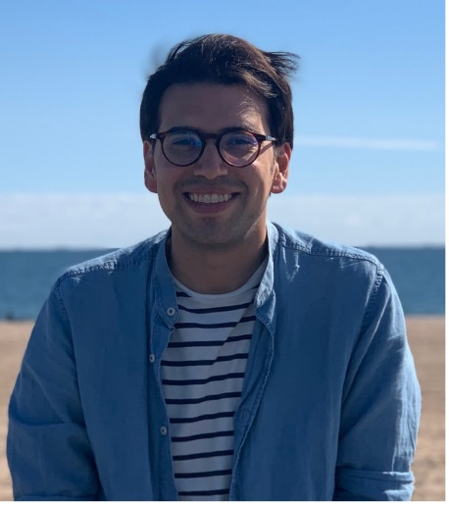
Santiago Virgüez is a PhD student in Political Science. He is a lawyer and holds a Master’s in Law from Stanford Law School. His research interests encompass topics related to comparative law and courts, transnational policing, and computational social science. Most of his work has focused on the creation and evolution of coalitions of interest groups around the Inter-American Court of Human Rights, and the strategic interactions between international and national courts in Latin America. He has also worked on methodological problems in text analysis and network analysis around these areas. His dissertation research examines the intersections between police-crafting and state-building, by focusing on how policing has been shaped and organized transnationally in connection with processes of state-building led by foreign actors, and how transnational networks on policing have conditioned the possibilities of reform in Central America and South America.

